Dashboard: Crypto wallet dashboard

**Level 1:**

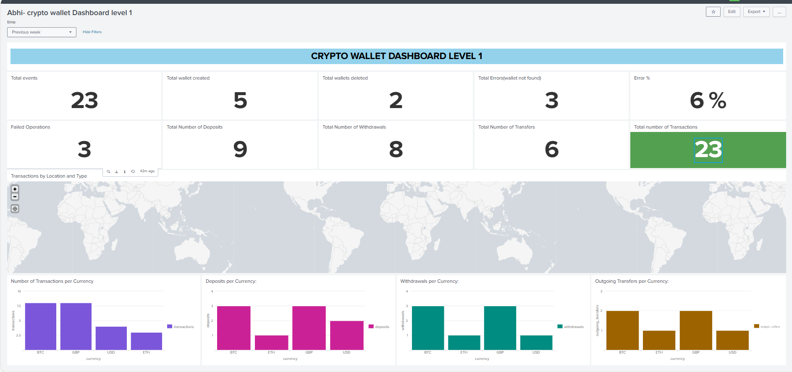

1. Panel 1: Total events

index=otel

| eval is_transaction=if(match(_raw,"Deposited") OR match(_raw,"Withdrew") OR match(_raw,"Transferred"), 1, 0)

| where is_transaction=1

| stats count AS "Total Transactions"

1. Panel 2: Total wallet created

index=otel "Created wallet"

| stats count as "Total Wallets Created"

1. Panel 3: Total wallets deleted

index=otel "Deleted wallet" | stats count as "Total Wallets Deleted"

1. Panel 4: Total Errors(wallet not found)

index=otel host=cryptowallet-* "not found"

| stats count as "Total Errors"

1. Panel 5: Error %

index=otel host=cryptowallet-* | eval is_error=if(like(_raw,"%not found%"),1,0) | stats count as total_events sum(is_error) as total_errors | eval error_percentage = round((total_errors/total_events)*100,2) | fields error_percentage

1. Panel 6: Failed Operations

index=otel host=cryptowallet-* "not found"

| stats count AS "Failed Operations"

1. Panel 7: Total Number of Deposits

index="otel" wallet

| where like(_raw, "Deposited%")

| stats count as total_deposits

1. Panel 8: Total Number of Withdrawals

index="otel" wallet

| where like(_raw, "Withdrew%")

| stats count as total_withdrawals

1. Panel 9: Total Number of Transfers

index="otel" wallet

| where like(_raw, "Transferred%")

| stats count as total_transfers

1. Panel 10: Total number of Transactions

index="otel" wallet

| eval is_transaction=if(like(_raw,"Deposited%") OR like(_raw,"Withdrew%") OR like(_raw,"Transferred%"), 1, 0)

| stats sum(is_transaction) as total_transactions

1. Panel 11: Transactions by Location and Type:

index=otel "wallet"

| rex field=_raw "Transferred\s+(?<amount>\d+)\s+(?<currency>[A-Z]{3})\s+from wallet\s+(?<from_wallet>[0-9a-f-]+)\s+at location\s+(?<from_location>[^,]+),\s+latitude\s+(?<from_lat>[-\d\.]+),\s+longitude\s+(?<from_lon>[-\d\.]+)\s+to\s+(?<to_amount>\d+)\s+(?<to_currency>[A-Z]{3})\s+in wallet\s+(?<to_wallet>[0-9a-f-]+)\s+at location\s+(?<to_location>[^,]+),\s+latitude\s+(?<to_lat>[-\d\.]+),\s+longitude\s+(?<to_lon>[-\d\.]+)"

| eval amount=tonumber(amount), to_amount=tonumber(to_amount)

| eval from_lat=tonumber(from_lat), from_lon=tonumber(from_lon), to_lat=tonumber(to_lat), to_lon=tonumber(to_lon)

| geostats latfield=from_lat longfield=from_lon count by currency

1. Panel 12: Number of Transactions per Currency

index="otel" wallet

| eval type=case(

match(_raw,"Deposited"),"Deposit",

match(_raw,"Withdrew"),"Withdrawal",

match(_raw,"Transferred"),"Transfer"

)

| rex field=_raw "Deposited\s+\d+\s+(?<deposit_currency>\w+)"

| rex field=_raw "Withdrew\s+\d+\s+(?<withdraw_currency>\w+)"

| rex field=_raw "Transferred\s+\d+\s+(?<transfer_currency_from>\w+).*to\s+\d+\s+(?<transfer_currency_to>\w+)"

| eval currency=coalesce(deposit_currency, withdraw_currency, transfer_currency_from)

| stats count as transactions by currency

| sort -transactions

1. Panel 13: Deposits per Currency:

index="otel" wallet

| where like(_raw, "Deposited%")

| eval currency=mvindex(split(_raw," "),2)

| stats count as deposits by currency

1. Panel 14: Withdrawals per Currency:

index="otel" wallet

| where like(_raw, "Withdrew%")

| eval currency=mvindex(split(_raw," "),2)

| stats count as withdrawals by currency

1. Panel 15: Outgoing Transfers per Currency:

index="otel" wallet

| where like(_raw, "Transferred%")

| eval currency=mvindex(split(_raw," "),2)

| stats count as outgoing_transfers by currency

**Time feature:**

**Drilldown to level 2:**

**ADDED TITLE:**

<row>

<panel>

<html>

<h1 style="text-align: center; color: black; background-color:#94D2EC; padding: 15px; font-size: 30px;">CRYPTO WALLET DASHBOARD LEVEL 1</h1>

</html>

</panel>

</row>

**LEVEL 2:**

**Timerange feature and details feature**

**Panels:**

1. Number of Deposits per Wallet:

index="otel" host=cryptowallet-*

| regex _raw="Deposited"

| rex "wallet\s(?<wallet_id>[a-f0-9\-]{36})"

| stats count as deposits by wallet_id

| sort -deposits

1. Number of Withdrawals per Wallet:

index="otel" host=cryptowallet-*

| regex _raw="Withdrew"

| rex "wallet\s(?<wallet_id>[a-f0-9\-]{36})"

| stats count as withdrawals by wallet_id

| sort -withdrawals

1. Number of Transfers per Wallet:

index="otel" host=cryptowallet-*

| where like(_raw, "Transferred%")

| rex "from wallet\s(?<wallet_from>[a-f0-9\-]{36})"

| rex "to wallet\s(?<wallet_to>[a-f0-9\-]{36})"

| eval wallet_id=mvappend(wallet_from, wallet_to)

| mvexpand wallet_id

| stats count as transfers by wallet_id

| sort -transfers

1. Number of transactions per wallet:

index="otel" "wallet"

| eval is_transaction=if(match(_raw,"Deposited") OR match(_raw,"Withdrew") OR match(_raw,"Transferred"), 1, 0)

| where is_transaction=1

| rex field=_raw max_match=2 "wallet\s(?<wallet_id>[a-f0-9]{8}-[a-f0-9]{4}-[a-f0-9]{4}-[a-f0-9]{4}-[a-f0-9]{12})"

| mvexpand wallet_id

| stats count as transactions by wallet_id

| sort -transactions

**Drill down feature implemented: The level 1 detailed drill down in level 2**

index=otel host=cryptowallet-*

| eval category=case(

match(_raw,"Created wallet"),"wallets_created",

match(_raw,"Deleted wallet"),"wallets_deleted",

match(_raw,"Deposited"),"deposits",

match(_raw,"Withdrew"),"withdrawals",

match(_raw,"Transferred"),"transfers",

like(_raw,"%not found%"),"errors",

true(),"events")

| eval selected="$wallet_id$"

| where isnull(selected)

OR selected="all"

OR (selected="transactions" AND category IN ("deposits","withdrawals","transfers"))

OR category=selected

| rex field=_raw "wallet\s(?<wallet_id>[a-f0-9\-]{36})"

| rex field=_raw "username\s(?<username>\w+)"

| rex field=_raw "location\s(?<location>[^,]+),\s+latitude\s(?<latitude>[-\d\.]+),\s+longitude\s(?<longitude>[-\d\.]+)"

| table _time category wallet_id username location latitude longitude

| sort -_time

**Drilldown of level 2 : Going to level 3:(same for every panels)**

**LEVEL 3:**

**Time range and wallet id feature:**

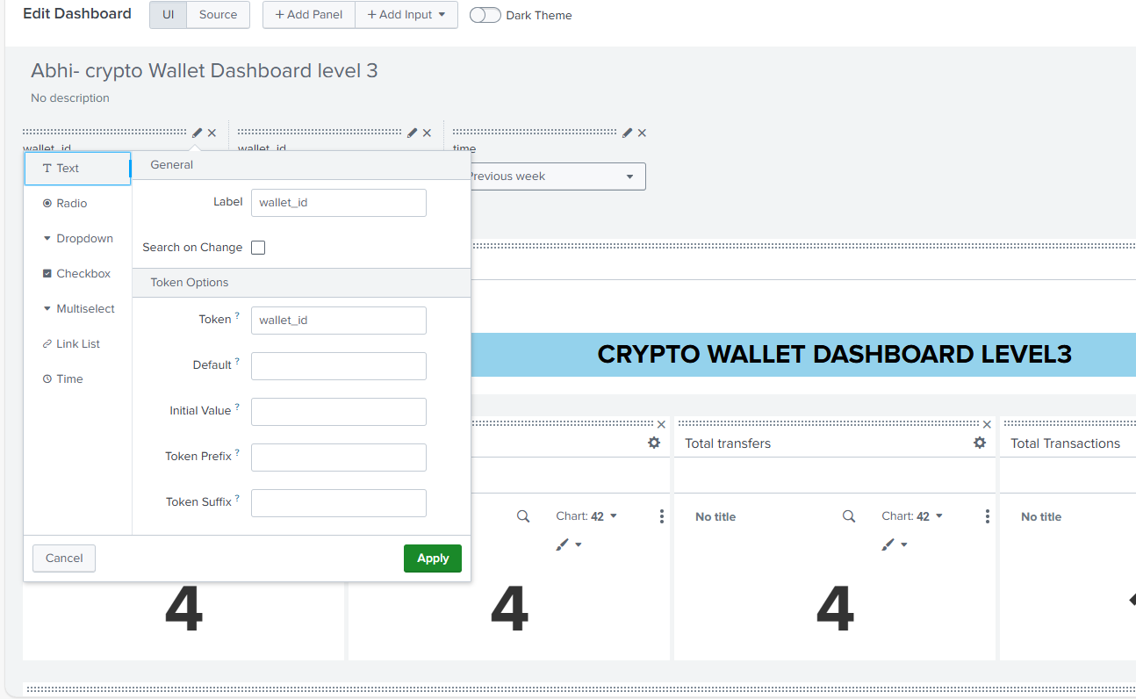

**Panels:**

1. Total deposits:

index=otel host=cryptowallet-*

| search "Deposited"

| rex "wallet (?<wallet_id_extracted>[a-f0-9\-]{36})"

| where wallet_id_extracted="$wallet_id$"

| stats count as total_deposits

1. Total withdrawals:

index=otel host=cryptowallet-*

| search "Withdrew"

| rex "wallet (?<wallet_id_extracted>[a-f0-9\-]{36})"

| where wallet_id_extracted="$wallet_id$"

| stats count as total_withdrawals

1. Total transfers:

index=otel host=cryptowallet-*

| search "Transferred"

| rex "wallet (?<wallet_id_extracted>[a-f0-9\-]{36})"

| where wallet_id_extracted="$wallet_id$"

| stats count as total_transfers

1. Total transactions:

index=otel host=cryptowallet-*

| rex "wallet (?<wallet_id_extracted>[a-f0-9\-]{36})"

| where wallet_id_extracted="$wallet_id$"

| eval is_transaction=if(like(_raw,"Deposited%") OR like(_raw,"Withdrew%") OR like(_raw,"Transferred%"), 1, 0)

| stats sum(is_transaction) as total_transactions

1. Total errors:

index="otel" host=cryptowallet-* wallet

| where like(_raw, "%not found%")

| rex "Wallet with ID (?<wallet_id_extracted>[a-f0-9\-]{36})"

| where wallet_id_extracted="$wallet_id$"

| stats count as total_errors

**DRILLDOWN**

**DRILLDOWN PANEL:**

1. Transaction details:

index=otel "wallet"

| rex "wallet (?<wallet_id_extracted>[a-f0-9\-]{36})"

| eval category=case(

match(_raw,"Deposited"),"deposits",

match(_raw,"Withdrew"),"withdrawals",

match(_raw,"Transferred"),"transfers"

)

| where (wallet_id_extracted="$wallet_id$" OR "$wallet_id$"="")

AND (

"$details$"="transactions"

OR category="$details$"

)

| rex field=_raw "(?i)(Deposited|Withdrew|Transferred) (?<amount>\d+) (?<currency>\w+)"

| rex field=_raw "from wallet (?<from_wallet>[a-f0-9\-]{36})"

| rex field=_raw "to (?<to_currency_amount>\d+ \w+) in wallet (?<to_wallet>[a-f0-9\-]{36})"

| rex field=_raw "location (?<city>[\w\s]+), latitude (?<lat>[\d\.]+), longitude (?<lon>[\d\.]+)"

| table _time category wallet_id_extracted from_wallet to_wallet amount currency city lat lon

1. Error details:

index=otel "wallet"

| eval category=case(

match(_raw,"Wallet with ID.*not found"),"errors"

)

| eval wallet_id_extracted=mvindex(split(replace(_raw,"Wallet with ID ","")," "),0)

| eval error_type=if(match(_raw,"Wallet with ID.*not found"),"Wallet Not Found","Other Error")

| where category="$error_token$" AND (wallet_id_extracted="$wallet_id$" OR "$wallet_id$"="")

| table _time wallet_id_extracted error_type _raw

| sort -_time

Screenshots:

